**Week 2: Programming Practice**

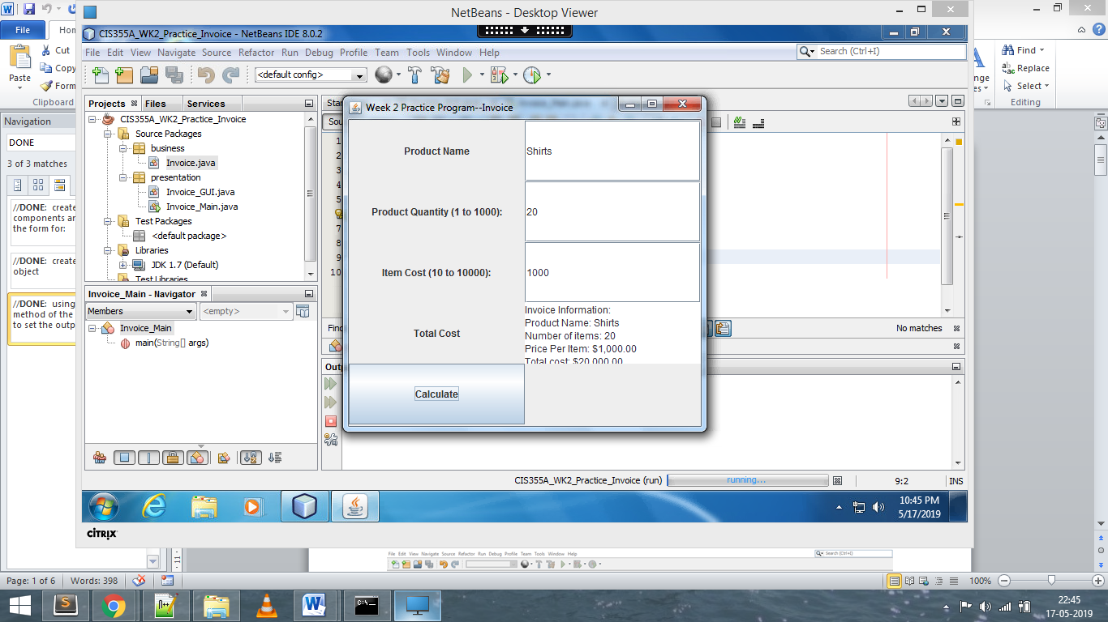

**CODE:**

package presentation;

import business.Invoice;

import java.awt.Dimension;

import java.awt.GridBagConstraints;

import java.awt.GridBagLayout;

import java.awt.GridLayout;

import java.awt.Insets;

import java.awt.event.ActionEvent;

import java.awt.event.ActionListener;

import javax.swing.JButton;

import javax.swing.JFrame;

import javax.swing.JLabel;

import javax.swing.JOptionPane;

import javax.swing.JTextArea;

import javax.swing.JTextField;

public class Invoice_GUI extends JFrame {

public static final int WINDOW_WIDTH = 450;

public static final int WINDOW_HEIGHT = 400;

private Invoice aInvoice;

private JButton btnCalculate;

private JButton btnClear;

private JButton btnExit;

private JTextField txtProductName;

private JTextField txtQuantity;

private JTextField txtCostPerItem;

private JTextArea txtTotalCost;

public Invoice_GUI() {

super();

createPanel();

setFrame();

}

private void createPanel() {

super.setLayout(new GridLayout(0, 2));

//TODO: create the GUI components and add them to the form for:

/*

1. Product name label

2. Product name textfield (name: txtProductName)

3. Quantity label

4. Quanitity textfield (name: txtQuantity)

5. Item cost label

6. Item cost textfield (name: txtCost)

7. JButton to calculate the cost (name: btnCalculate

8. Add a CalculateHandler handler object to the btnCalculate addActionListener

*/

JLabel lblProduct = new JLabel("Product Name");

lblProduct.setHorizontalAlignment( JLabel.CENTER );

this.add(lblProduct);

txtProductName = new JTextField(10);

this.add(txtProductName);

JLabel lblQuantity = new JLabel("Product Quantity (1 to 1000):");

lblQuantity.setHorizontalAlignment( JLabel.CENTER );

this.add(lblQuantity);

txtQuantity = new JTextField(10);

this.add(txtQuantity);

JLabel lblCost = new JLabel("Item Cost (10 to 10000):");

lblCost.setHorizontalAlignment( JLabel.CENTER );

this.add(lblCost);

txtCostPerItem = new JTextField(10);

this.add(txtCostPerItem);

JLabel lblTotalCost = new JLabel("Total Cost");

lblTotalCost.setHorizontalAlignment( JLabel.CENTER );

this.add(lblTotalCost);

txtTotalCost = new JTextArea();

this.add(txtTotalCost);

btnCalculate = new JButton("Calculate");

btnCalculate.addActionListener(new CalculateHandler() );

this.add(btnCalculate);

}

private void setFrame() {

Dimension windowSize = new Dimension(WINDOW_WIDTH, WINDOW_HEIGHT);

super.setTitle("Week 2 Practice Program--Invoice");

super.setDefaultCloseOperation(JFrame.EXIT_ON_CLOSE);

super.setSize(windowSize);

super.setMinimumSize(windowSize);

super.setMaximumSize(windowSize);

super.setLocationRelativeTo(null);

super.setVisible(true);

}

private class CalculateHandler implements ActionListener {

@Override

public void actionPerformed(ActionEvent ae) {

boolean valid;

if (aInvoice == null) {

//TODO: create a new invoice object

aInvoice = new Invoice();

}

aInvoice.setProductName(txtProductName.getText());

try {

int quanity = Integer.parseInt(txtQuantity.getText());

aInvoice.setQuantityPurchased(quanity);

valid = true;

}

catch (NumberFormatException ex) {

JOptionPane.showMessageDialog(null, "Quantity needs to be a number between 1 and 1000",

"Illegal Quanity value",

JOptionPane.ERROR_MESSAGE);

valid = false;

txtQuantity.setText("");

txtQuantity.requestFocus();

}

if (valid) {

try {

double cost = 0;

//TODO: write the state to extract the double value from the txtCost field

cost = Double.parseDouble( txtCostPerItem.getText() );

aInvoice.setPricePerItem(cost);

}

catch (NumberFormatException ex) {

valid = false;

JOptionPane.showMessageDialog(null, "Costs needs to be a number between 10 and 10000",

"Illegal Cost value",

JOptionPane.ERROR_MESSAGE);

valid = false;

txtCostPerItem.setText("");

txtCostPerItem.requestFocus();

}

}

if (valid) {

//TODO: using the toString method of the invoice object to set the output text

txtTotalCost.setText(aInvoice.toString() );

}

}

}

}