**Querying the Database With SQL**

Lisa Frazier

BIAM530-Week 3 Lab

November 13, 2023

Professor Sid Ahmed

**Sales by Territory:**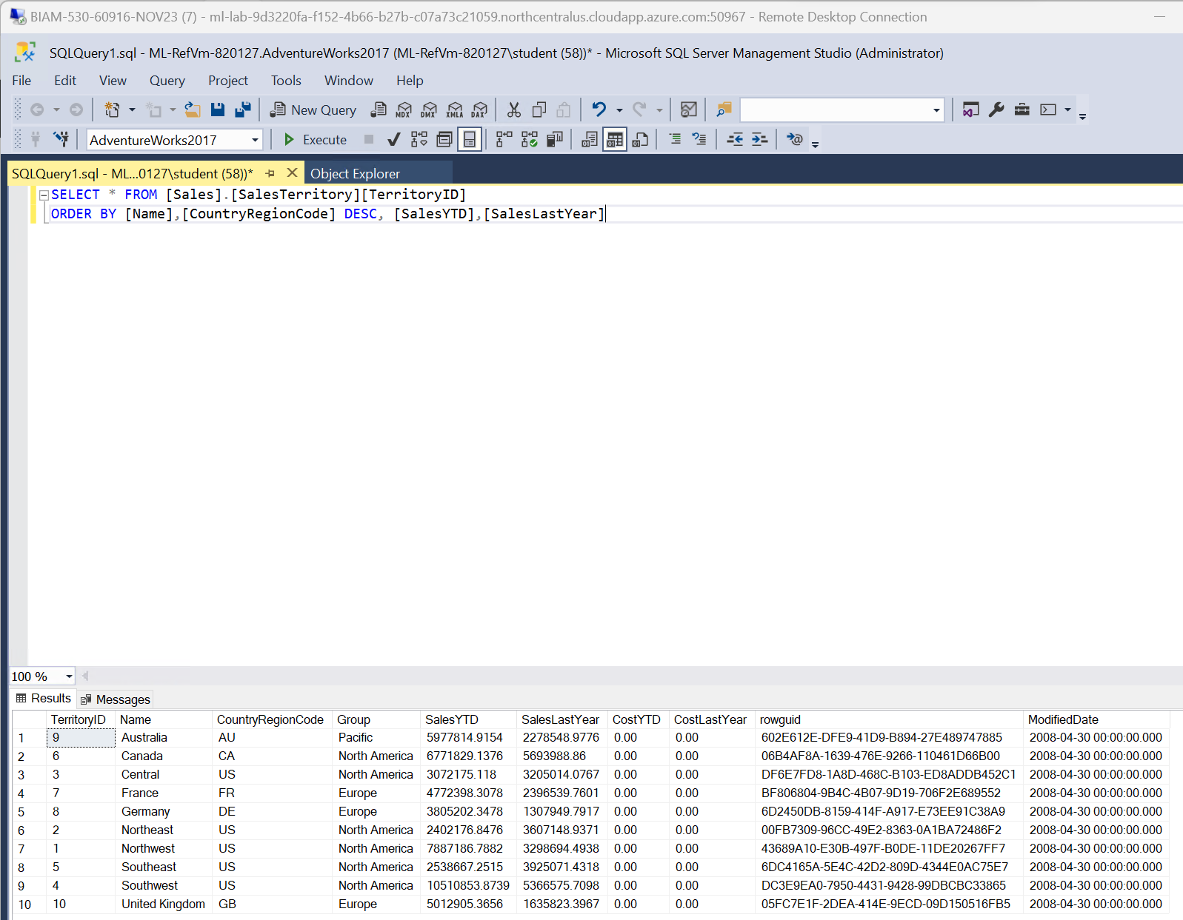

* **Based on the table shown for Sales by Territory, territory 10, United Kingdom in column Country Region, from Europe shows a significant increase in salesYTD, stated 50,129.053.656 compared to Sales Last Year at 16,358.233.967.** **This positive trend in sales could be attributed to various factors such as increased demand, successful marketing strategies, economic conditions, or other business-specific factors. This analysis was done from a perspective of a query database using:**
* **SELECT * FROM Sales.SalesTerritory TerritoryID**
* **GROUP BY Name, CountyRegionCode DESC, SalesYTD, SalesLastYear.**

**Sales by Country:**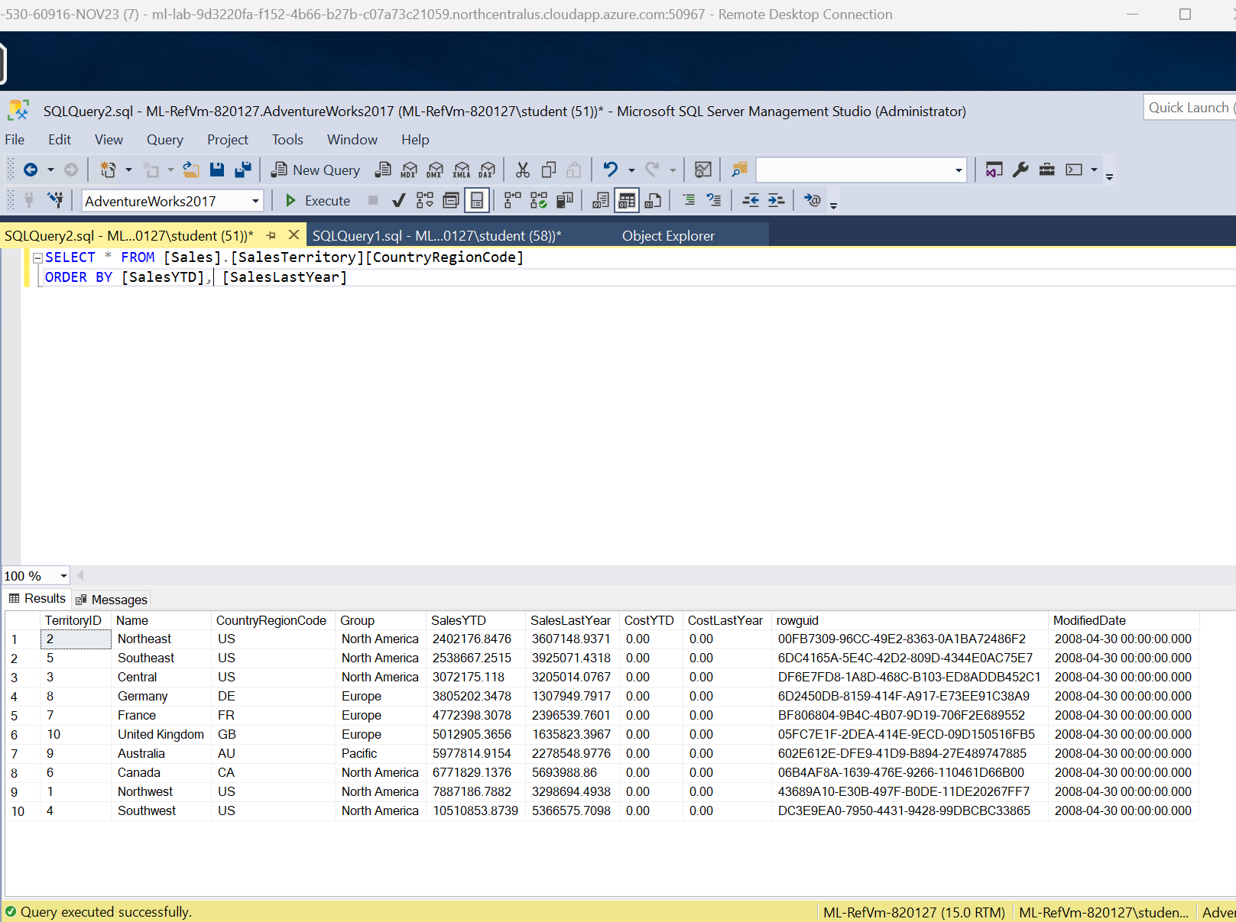

* **Based on the table shown for Sales by Country, Country Region Code shows Southwest territory ID #4 doubled sales than last year. Table shows 105,108.538.739 Year to Date as opposed to last year 53,665.757.098. the reasons for this significant increase in sales could be multifaceted, including factors like increased demand, successful business strategies, market conditions, or other region-specific influences. This analysis was done from a perspective of a query database using:**
* **SELECT * FROM Sales.SalesTerritory CountyRegionCode**
* **ORDER BY SalesYTD, SalesLastYear**

**Sales Growth by U.S. Region:** 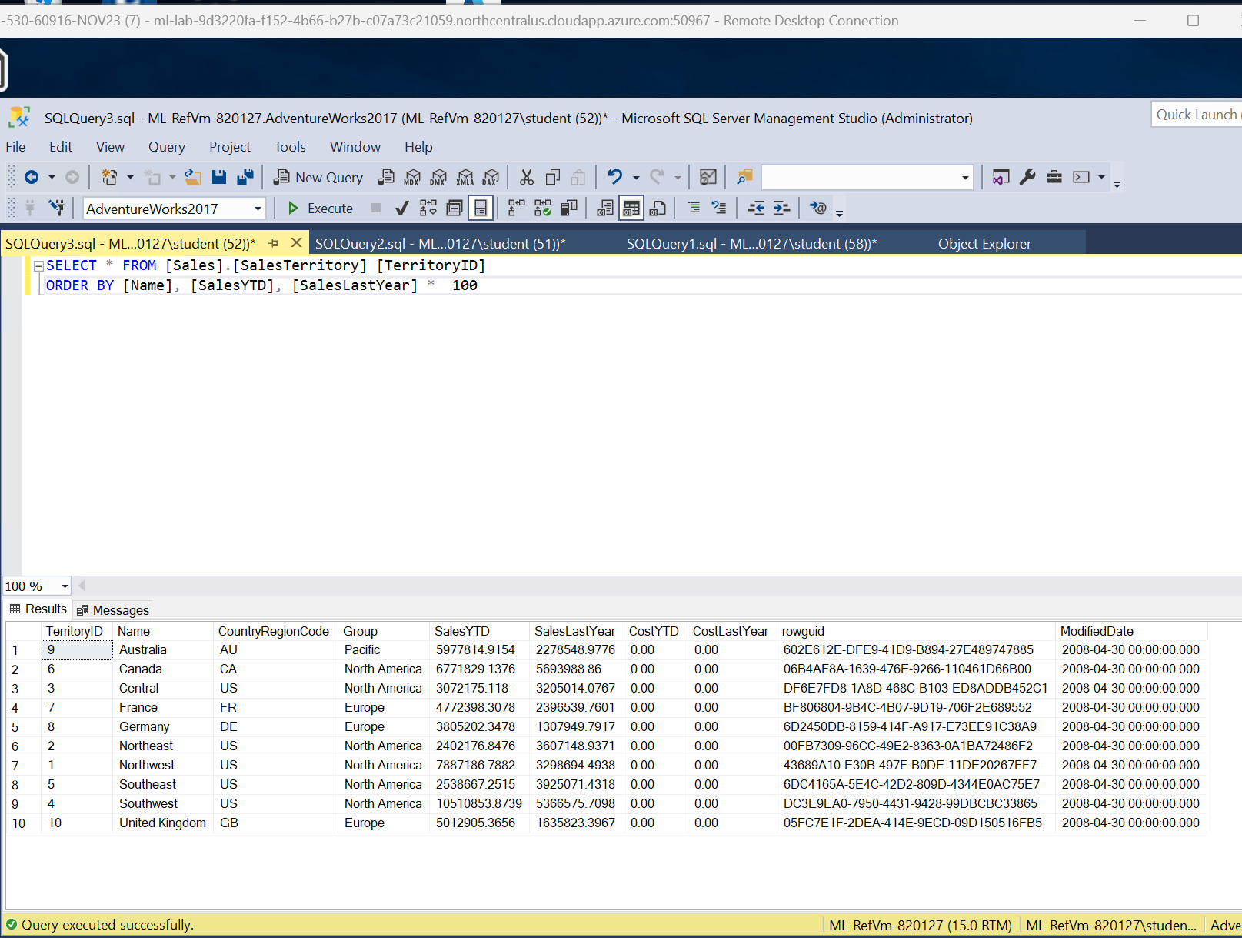

* **Based on the table shown for Sales Growth by U.S Region, territory 5, Southwest in U.S column Region, from North American shows less sales than territory 2, 1 and 5 decrease in salesYTD, stated 25.386.672.515 compared to Sales Last Year at 39.250.714.318. This analysis was done from a perspective of a query database using:**
* **SELECT * FROM Sales.SalesTerritory TerritoryID**
* **GROUP BY Name, SalesYTD, SalesLastYear * 100**

**Best-Selling Products:**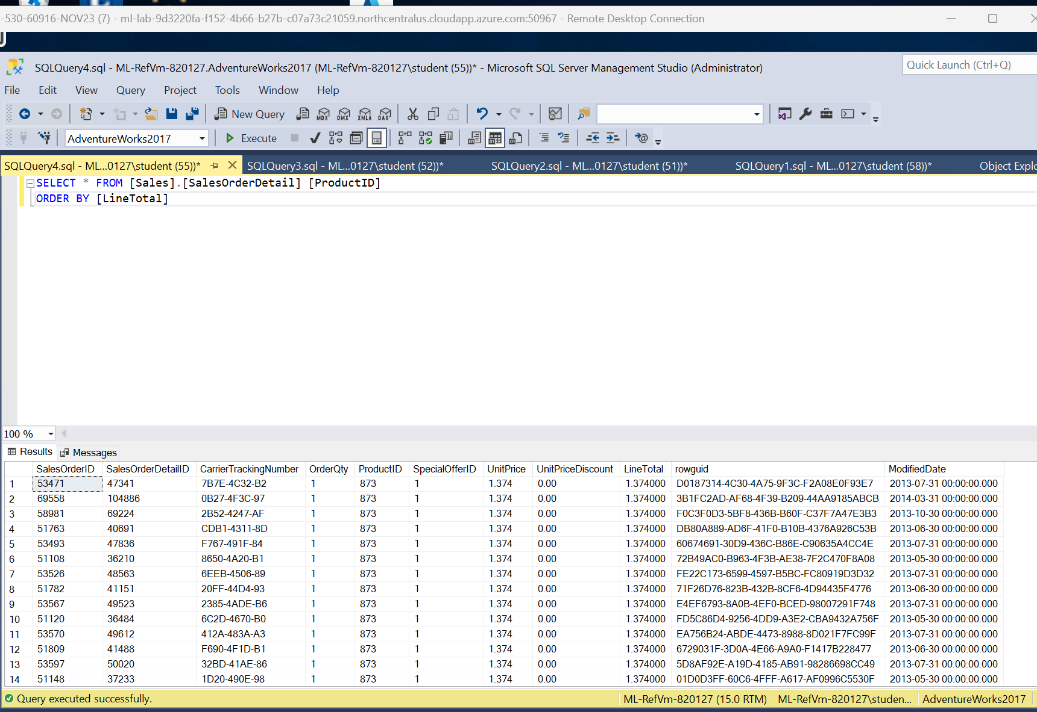

* **Based on the table shown for Best-Selling Products, all products were sold equally, from the OrderQty, and Line Total of 1.374000. This analysis was done from a perspective of a query database using:**
* **SELECT * FROM Sales.SalesOrderDetail ProductID**
* **GROUP BY LineTotal**

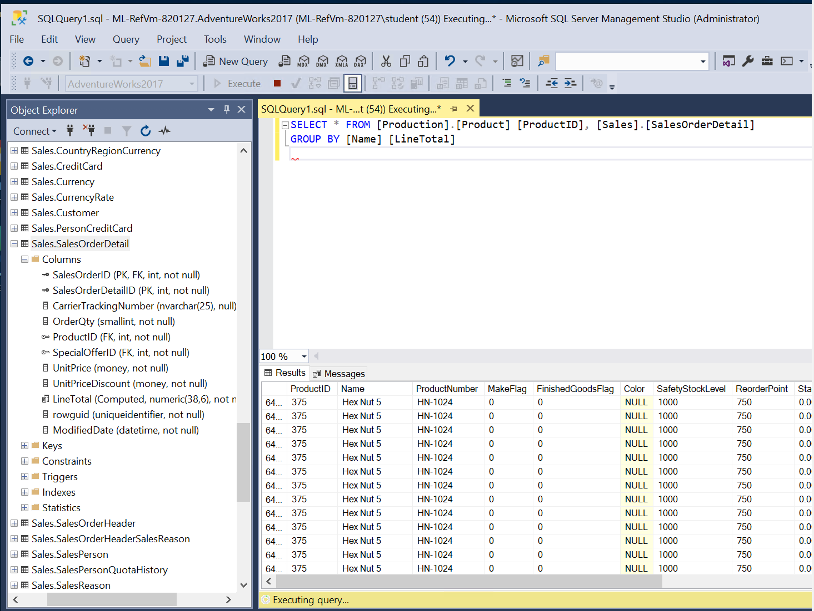

**Best-Selling Products with Produce Names:**

* **Based on the table shown for Best-Selling Products with Product Names, Hex Nut 5, from the Name column, has a sum of $2 million. This analysis was done from a perspective of a query database using:**
* **SELECT * FROM Production.Product, Product ID, Sales.SalesOrderDetail**
* **GROUP BY Name, LineTotal**

